**INCIDENT SEGMENT HIGHLIGHTING**

MADE BY:

* Mohammad Athania (Team Leader)
* Meghashyam Parab
* Jugal Chauhan

**TITLE : Gui Application for Object Tracking**

GUI application which allows you to track movements of any objects

**INTRODUCTION :**

We have created an app which would record and highlight the movement of the object in the video feed.

* This application also has a trackbar for traversing through the video
* The output window draws a highlight depicting the trajectory of motion of object

**INSTALLATION :**

You need to have the following installed on you PC:

* Python 3.6.8 : <https://www.python.org/downloads/>
* OpenCV library : <https://pypi.org/project/opencv-python/>
* Tesseract OCR library : <https://pypi.org/project/pytesseract/>
* Tkinter library : <https://docs.python.org/3/library/tkinter.html>
* Imutils library : <https://pypi.org/project/imutils/>
* Collection : <https://pypi.org/project/collections-extended/>

**FEATURES:**

* Object Tracking
* Save Video
* Video Playback
* Object Dimensions
* Save Text
* Close

**EXPLAINATION:**

* **Object Tracking:**

It tracks the movement of any objects present inside the frame and shows its trajectory path.

* **Save Video:**

It saves the video of your webcam feed in the same directory as a “.mp4” file.

* **Video Playback:**

It playbacks the video content of your webcam feed in a separate window and also provides a trackbar feature using which one can traverse to any specific frame of the feed.

* **Object Dimensions:**

This feature measures the size of an object in an image using OpenCV library by using ‘pixels per metric ratio’ to determine the size of an object. The size and area parameters of the object are then displayed as text in the frame.

* **Save Text:**

This functionality will save your area parameter of the image as a “.txt” file in the same directory.

* **Close:**

It will close all background windows running alongside and shut the program.

**RESULT:**

We have successfully created a GUI Application using Tkinter and other python functions which allows us to track the trajectory of moving objects in the frame and their path is depicted on the screen.

Attaching a few screenshots of our application :

1. This is the frontpage of our application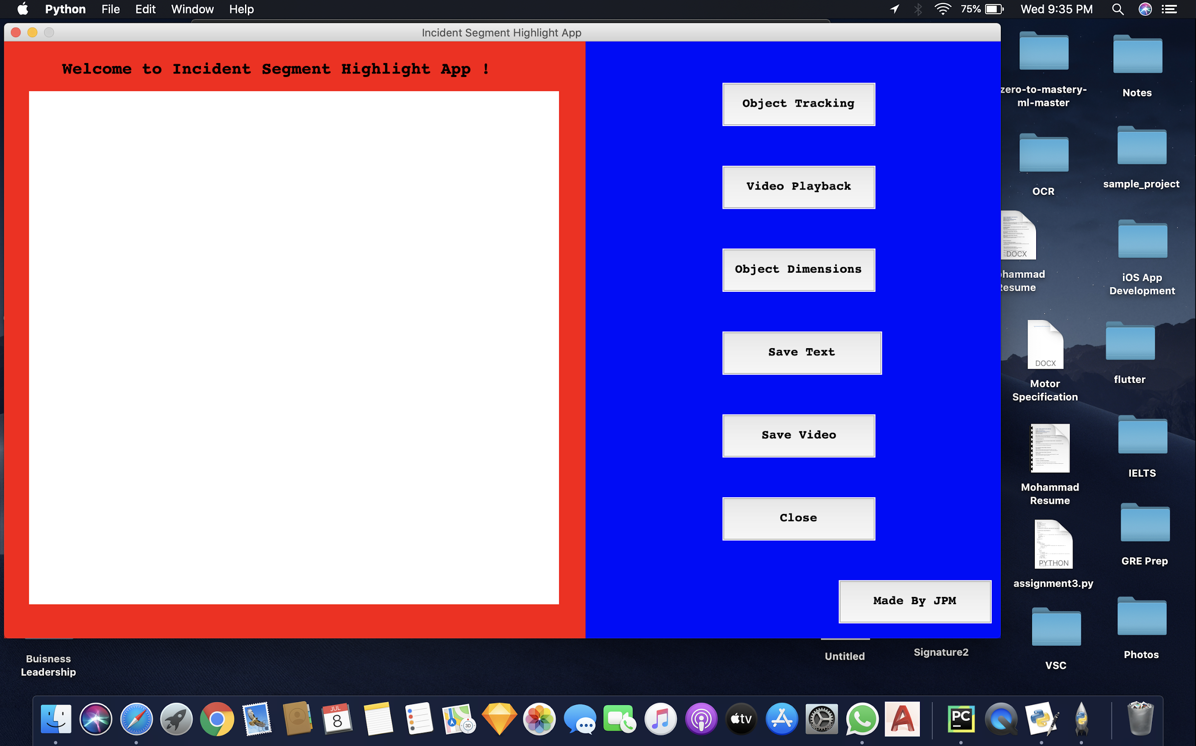
2. This is the Video Capture Frame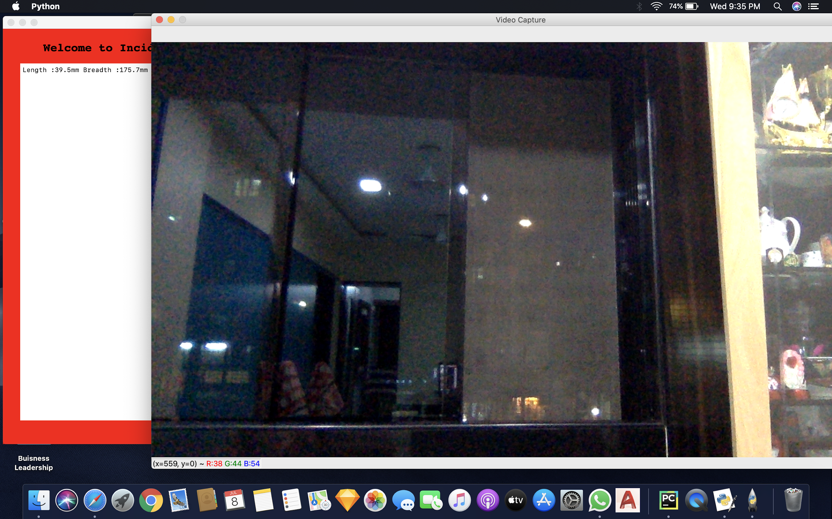
3. The frame shows the trajectory of the object recognized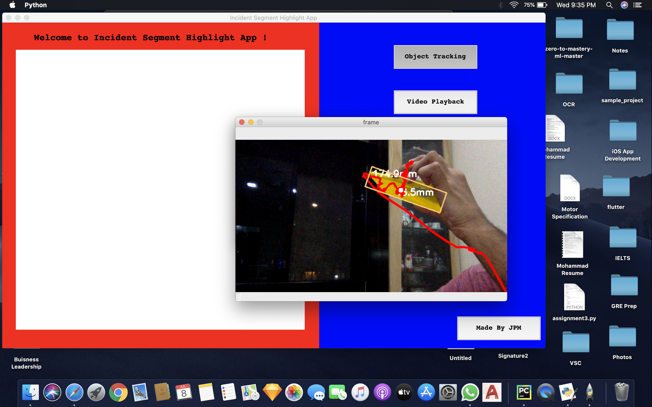
4. The Video Playback frame shows the trackbar to traverse in the feed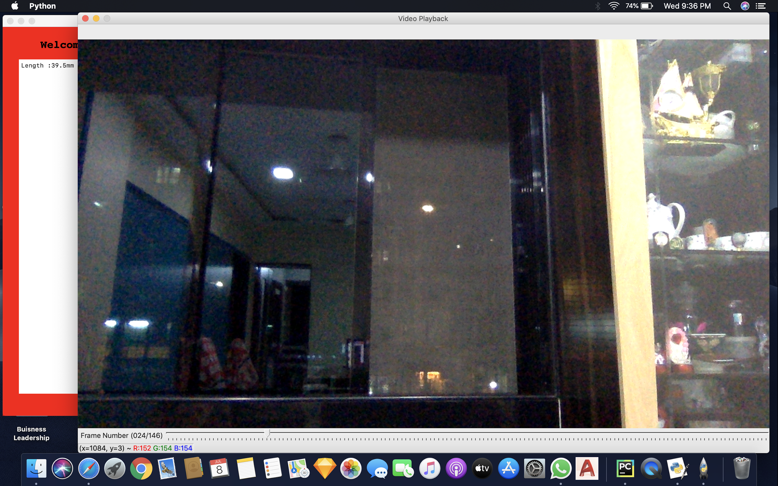
5. The dimensions and Area parameters of object are shown on the text frame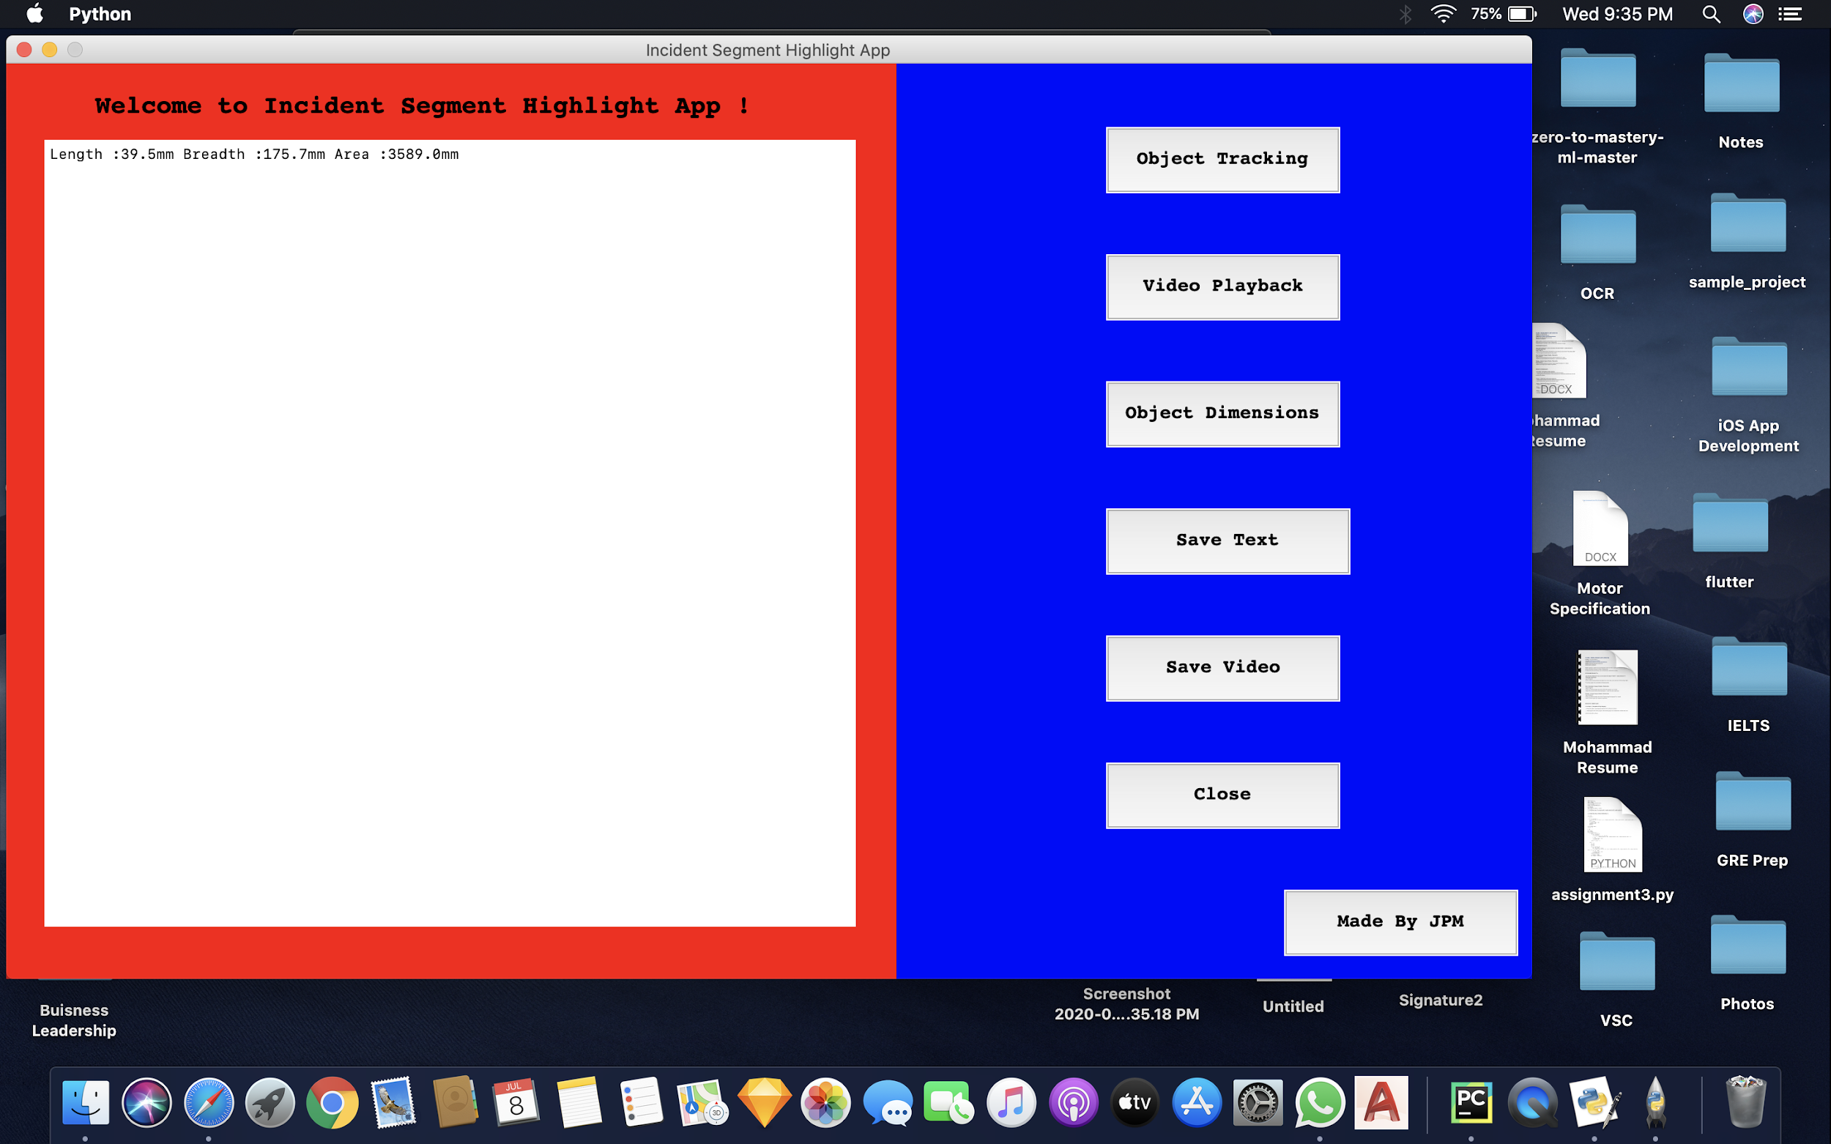

6. The Save Video and Save Text buttons saves the video file and text file in the same directory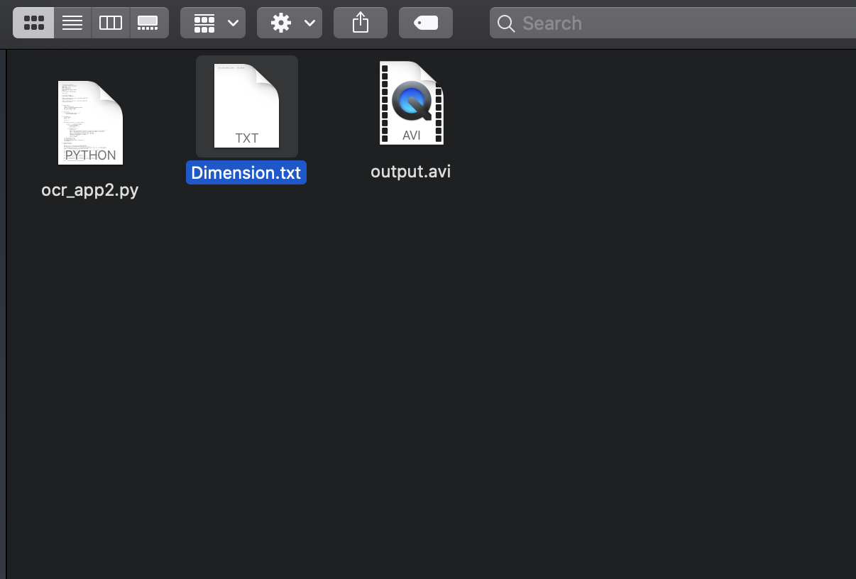

**Implementation Video :** <https://drive.google.com/drive/folders/18DwLyydKIWIVUSCAmsmYGhIvE5zbUTJv?usp=sharing>

**CONCLUSION:**

Successful implemented Incident Segment Highlighting using libraries and features of Python taught during the online sessions. We have created an app which would record and highlight the movement of the object in the video feed. The output window draws a highlight depicting the trajectory of motion of the object detected in the frame of live web-cam feed. This application also has an additional trackbar for traversing through the video recorded. We have attained our final product after an adequate amount of self study and numerous experiments while exploring the vast area of Image Processing.